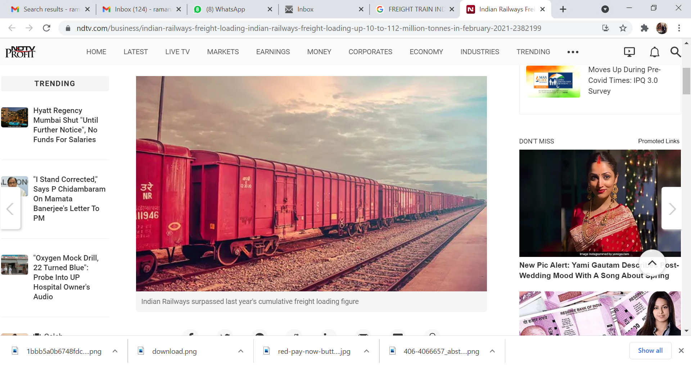**



**

**INDIAN RAILWAYS- FREIGHT BUSINESS DEVELOPMENT PORTAL**

**ONLINE PAYMENT SERVICE**

**FASTER, CONVENIENT & SECURE**

*Freight & Ancillary Charges Payments are now,*

*just a Click Away…*

**Visiting Freight Business Development (FBD) Portal**

**Option 1:** Visit [**https://indianrailways.gov.in**](https://indianrailways.gov.in)and click on **FREIGHT SERVICES -> Freight Business** menu item.

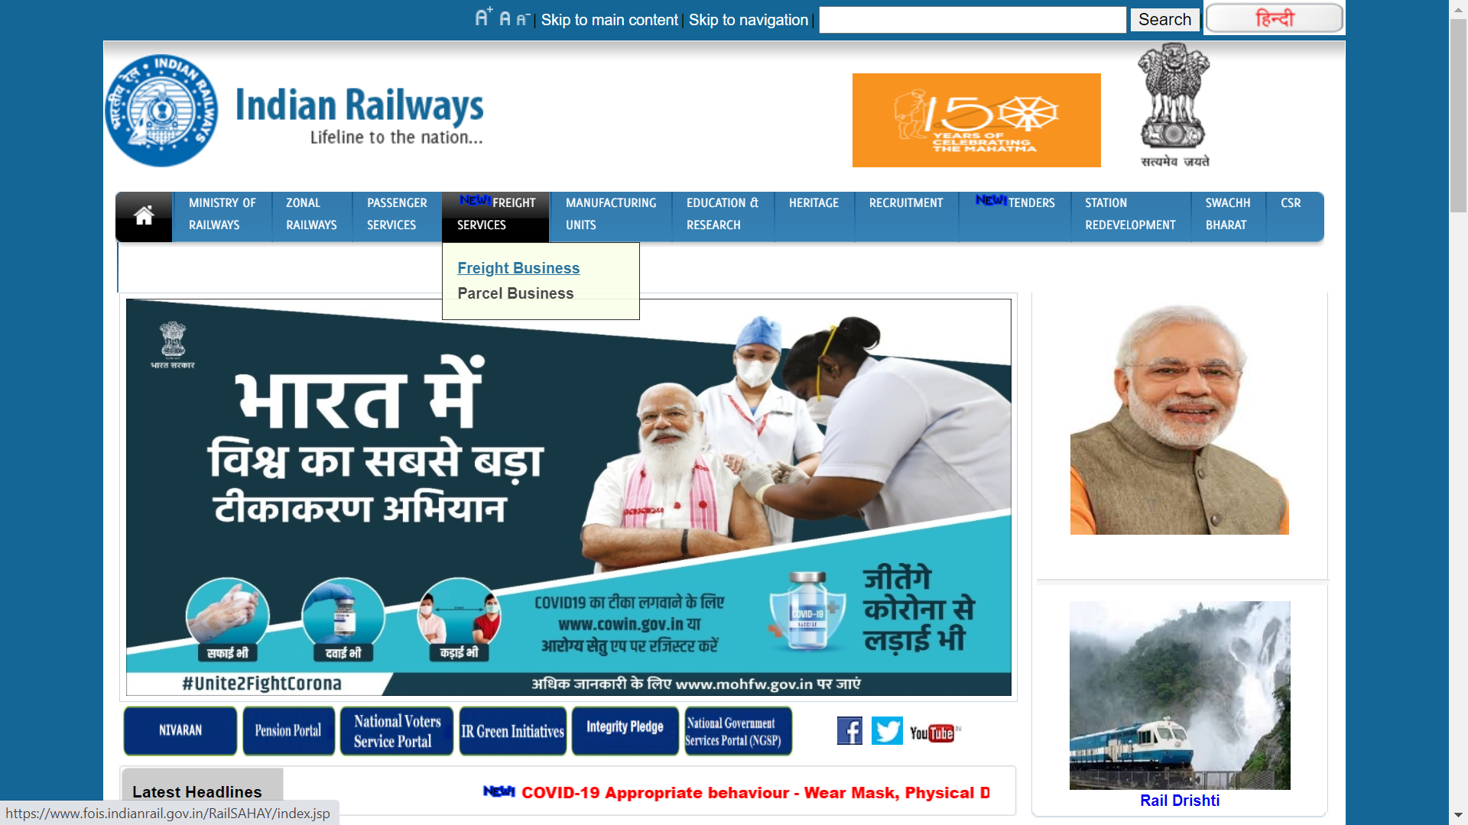

**Option 2:** Visit [**https://fois.indianrailways.gov.in**](https://fois.indianrailways.gov.in)and click on **FREIGHT BUSINESS** button  
  
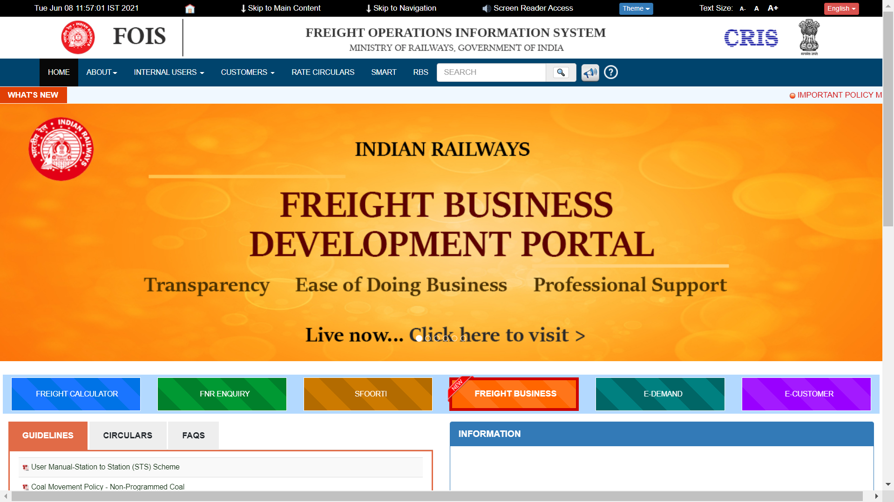

**Option 3:** Direct URL Link [**https://fois.indianrail.gov.in/RailSAHAY**](https://fois.indianrail.gov.in/RailSAHAY)

**Accessing Customer Dashboard (FBD Portal)**

**FBD Portal** is one stop solution for all the freight customers’ needs, providing myriad of information and services. In order to bring IR freight business closer to the customer, FBD portal is an innovative digital platform adding to ease of doing business.

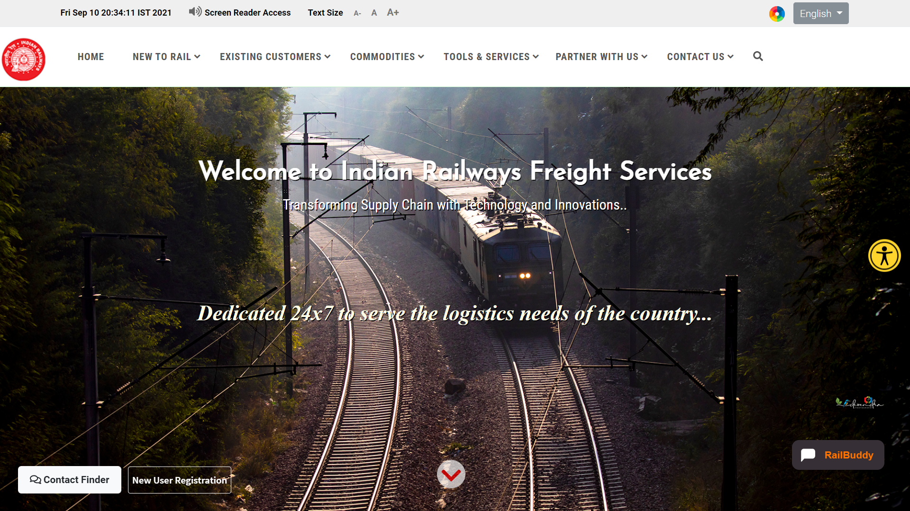

**Step 1:** Click on **EXISTING CUSTOMERS -> Individual Login** menu item.

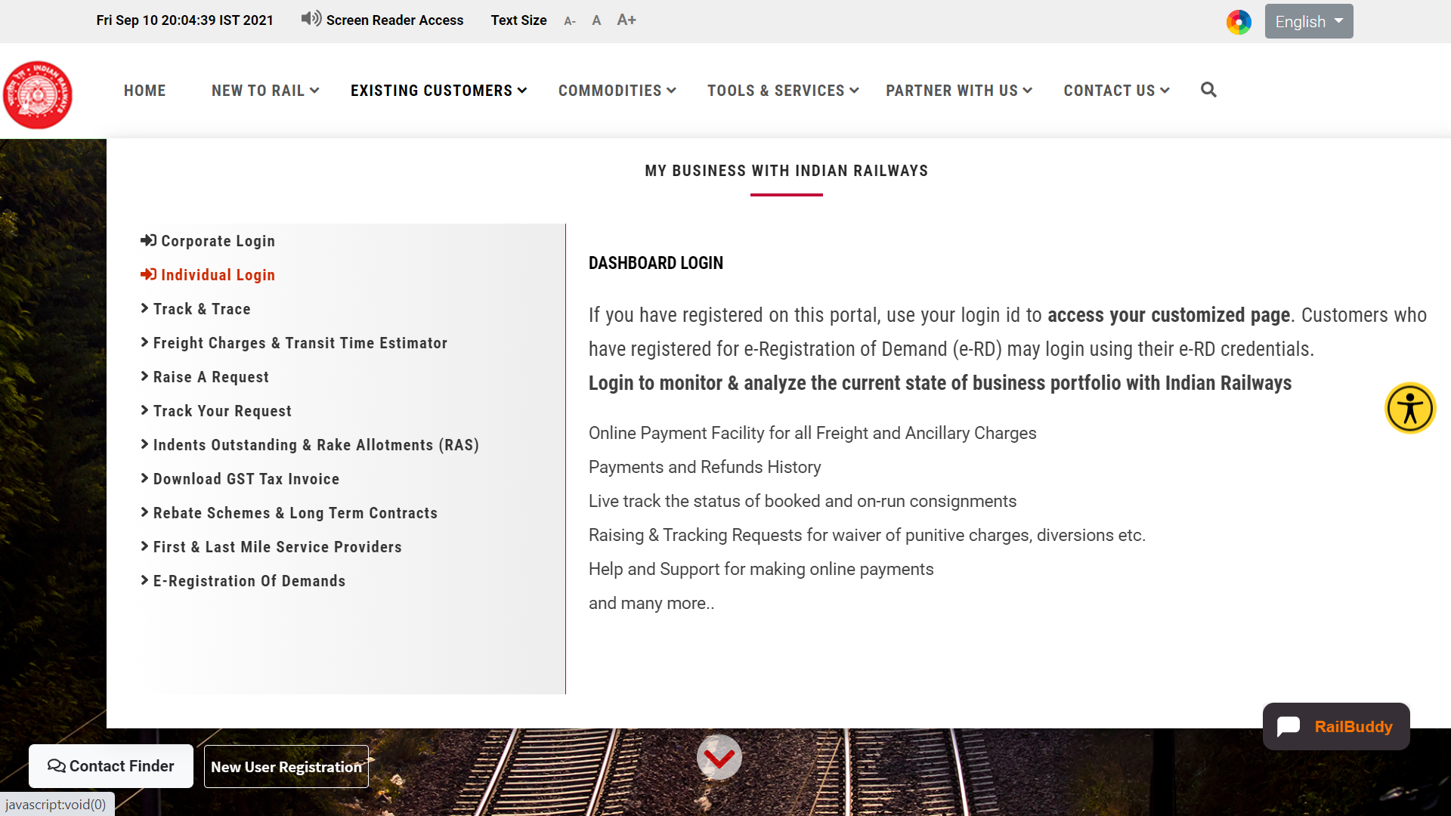

**Step 2:** Login with your FOIS e-RD (e-Registration of Demand) credentials.

****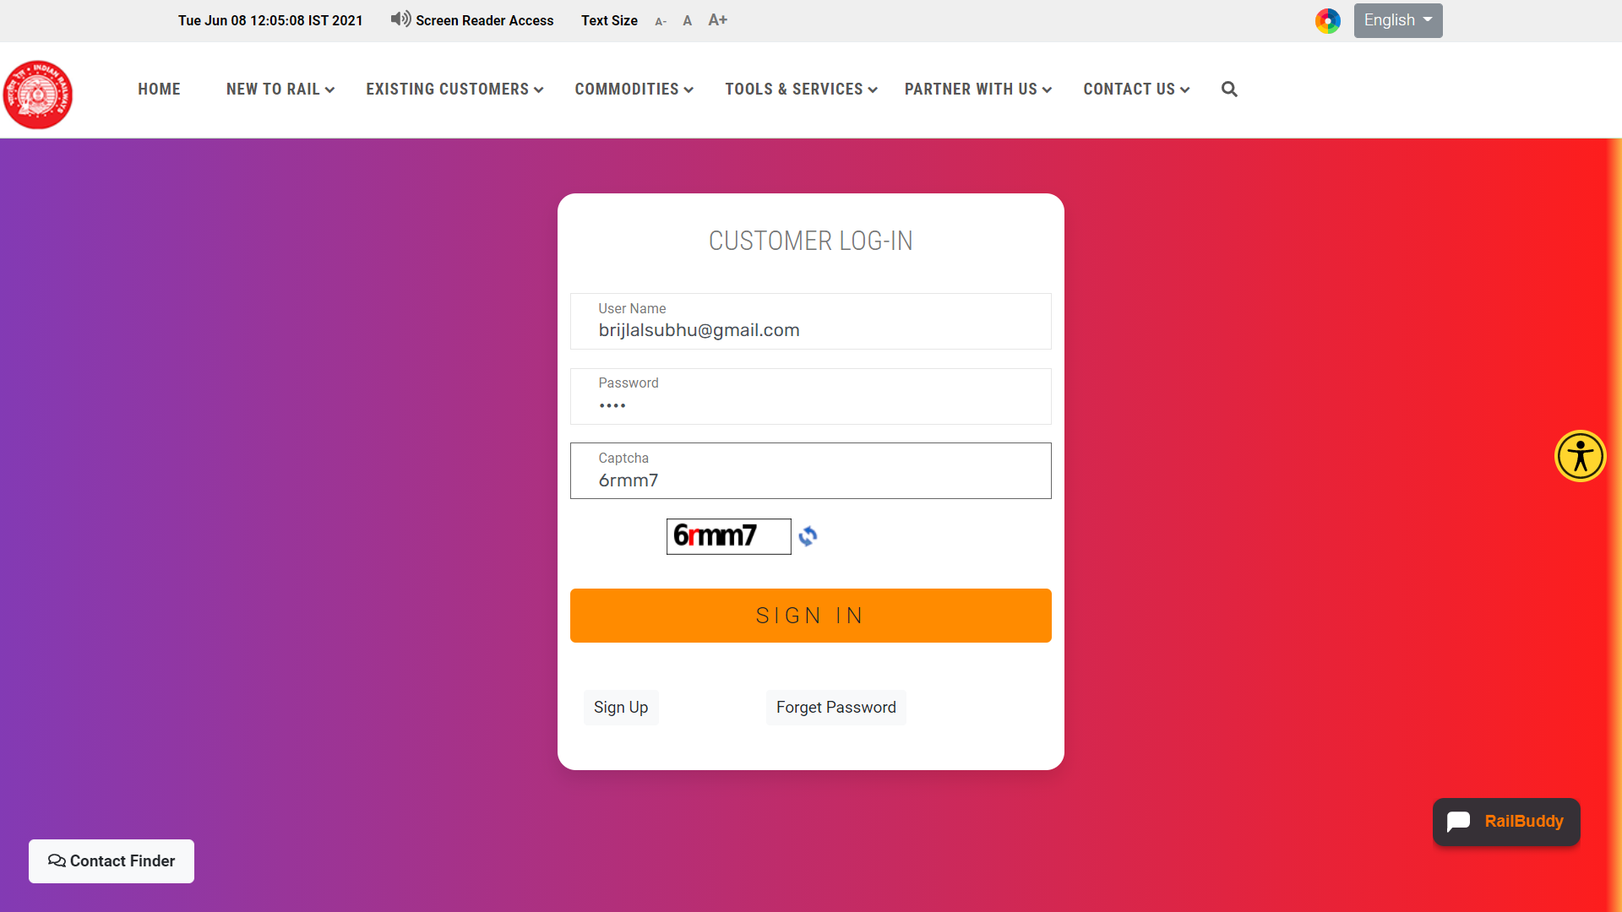

**Step 3:** After successful login,enter the Customer Dashboard, a personalized dashboard reflecting all your freight business with Indian Railways (IR) including  
Pending Payments, Payments History, Refund History, Outstanding Indents, On-Run Consignments, Registered Concerns and much more.

****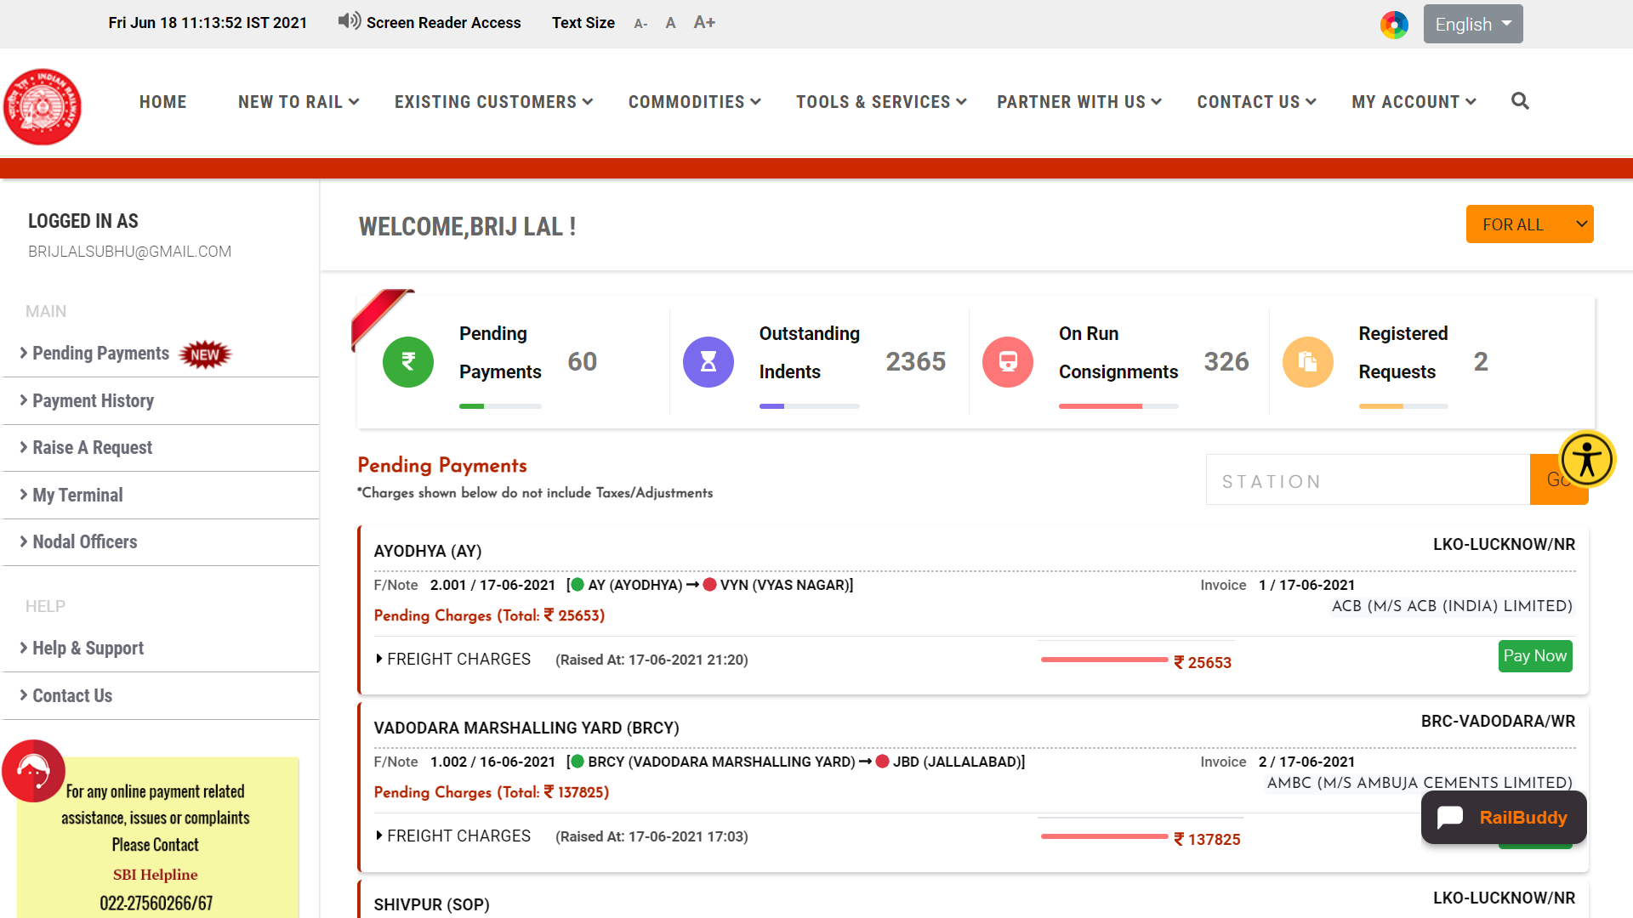

A **Primary customer** may make all the payments, pending on behalf of his organization/company.

A **Secondary customer** (Handling Agent) may make payments, pending on the any location(s) on behalf of all the primary customers (organizations) for which he’s registered as an handling agent in FOIS.

List of organizations (Primary/Secondary) is available at the top right corner of the pending payments view.

****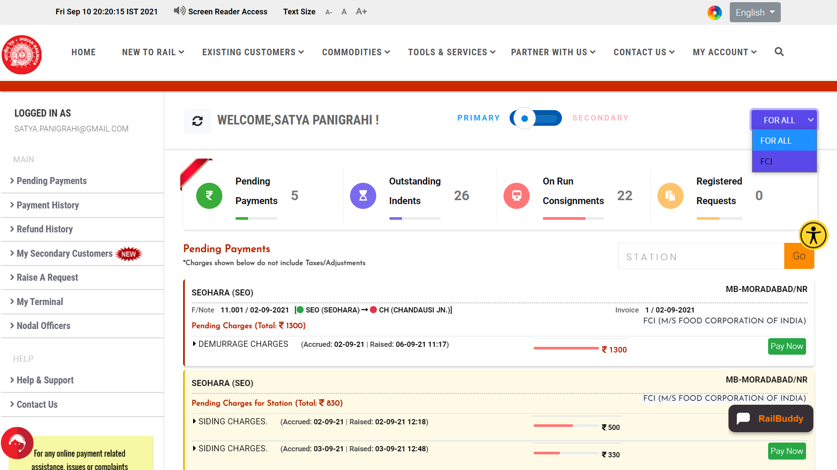

****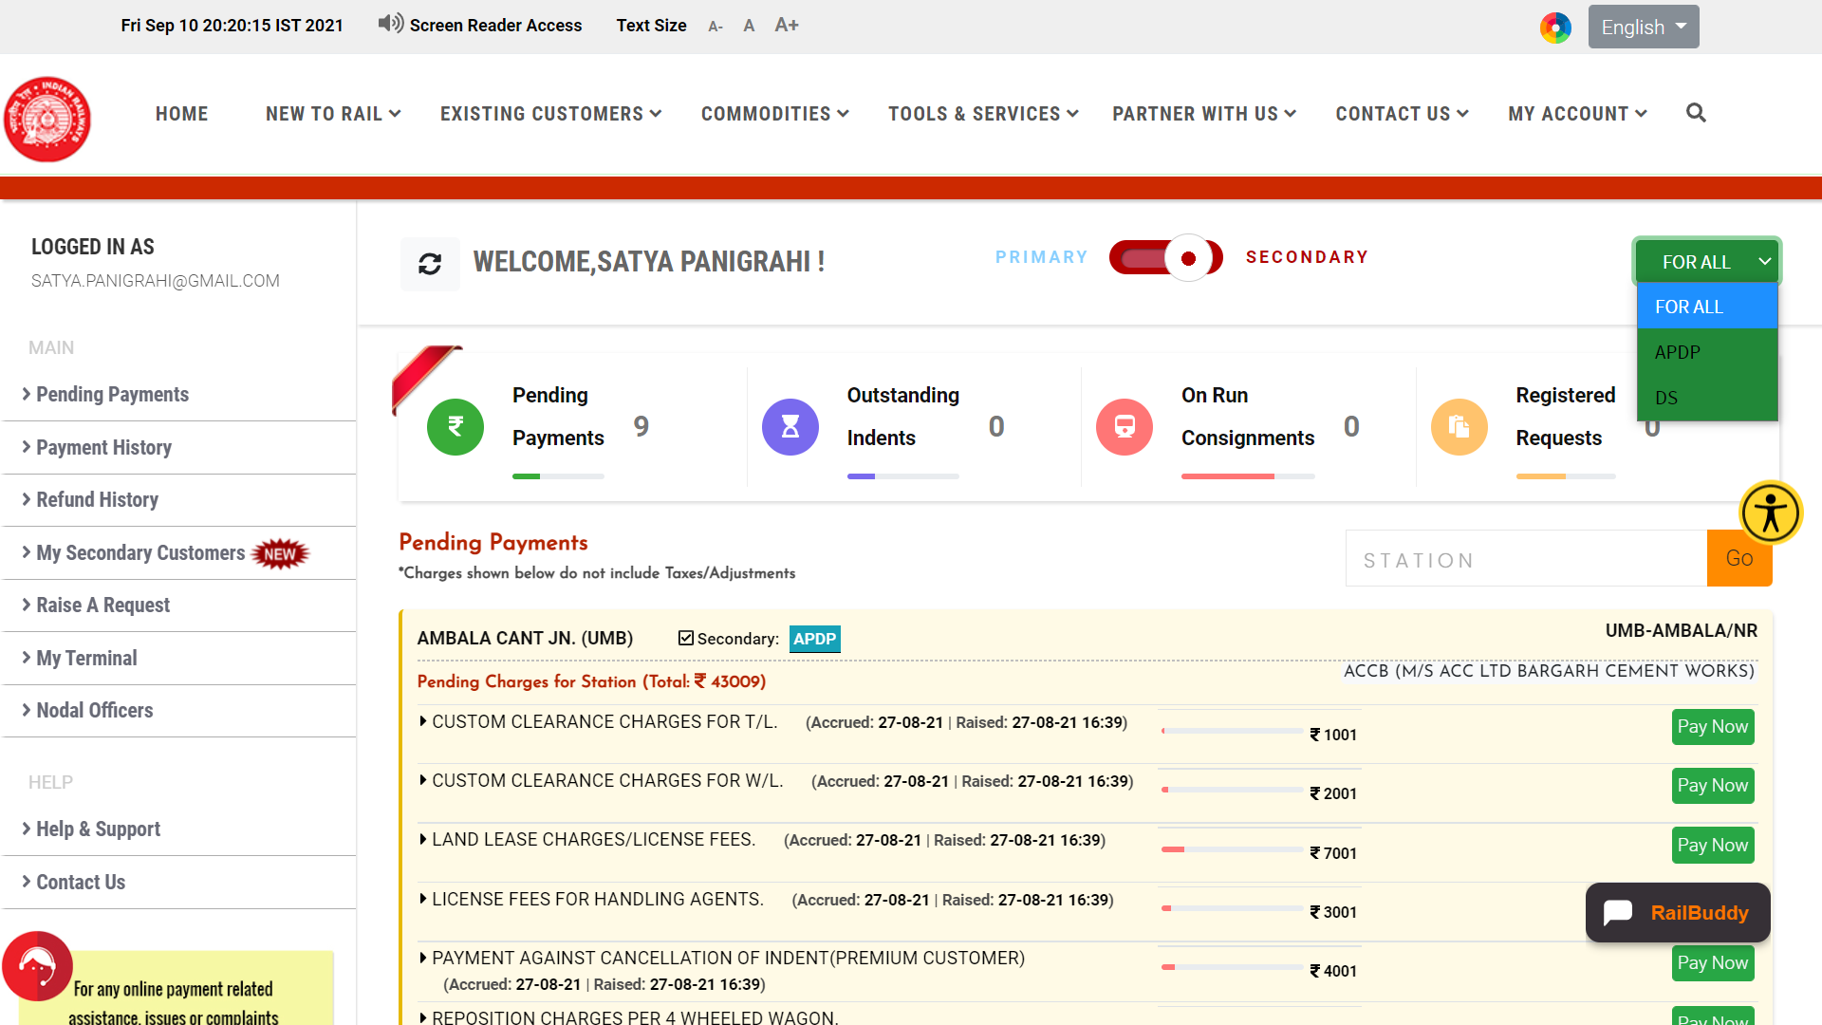

**Making online payment(s) of Freight and Ancillary Charge(s)**

**Step 1:** In the customer dashboard, click on **Pending Payments** to view the detail of all the outstanding charges (latest at the top), raised by IR Goods Clerk at respective loading stations.

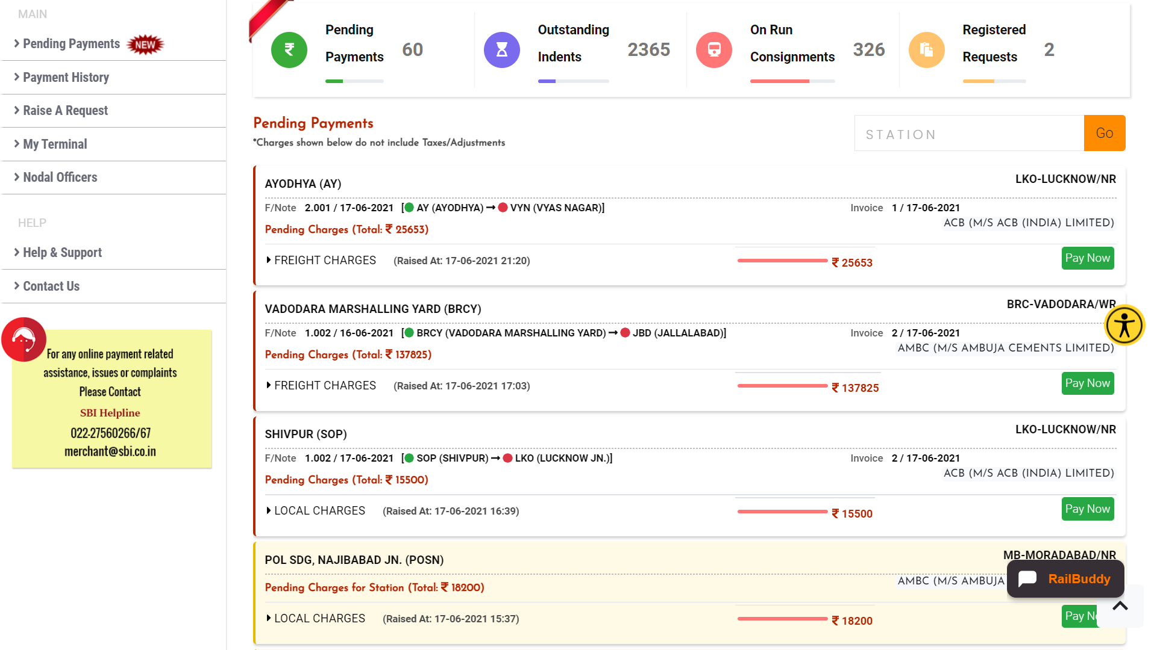

**Step 2:** Verify the detail of individual charge, click on displayed amount and get to know about taxes, adjustments and net payable amount for **Freight Charges** and for **Ancillary Charges**.

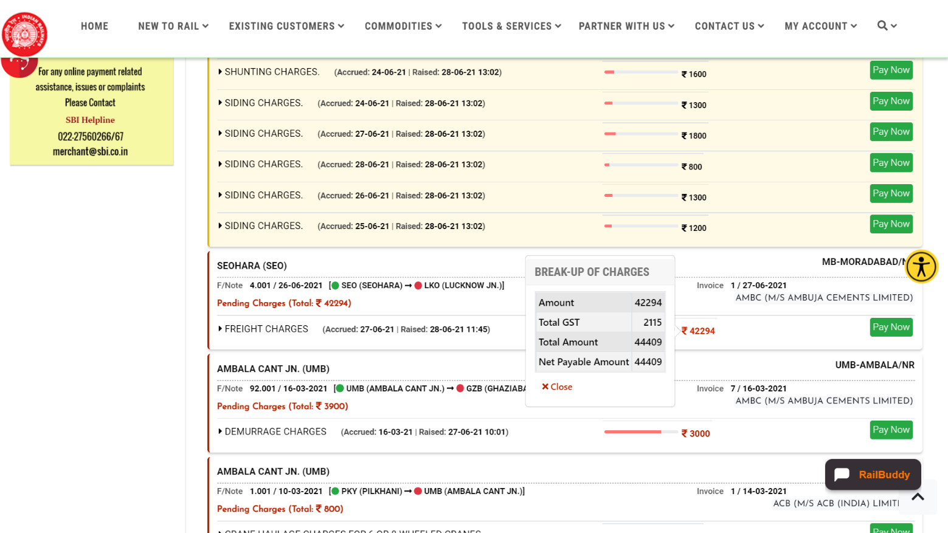

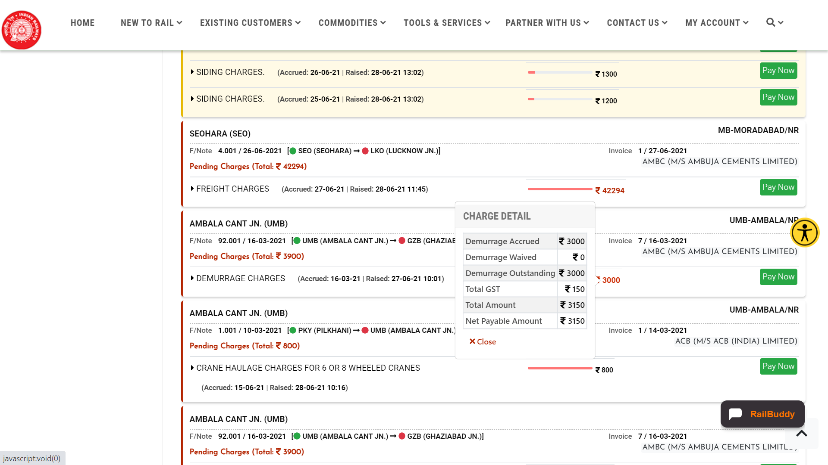

**Step 3:** Initiate the payment process through **Pay Now** option.

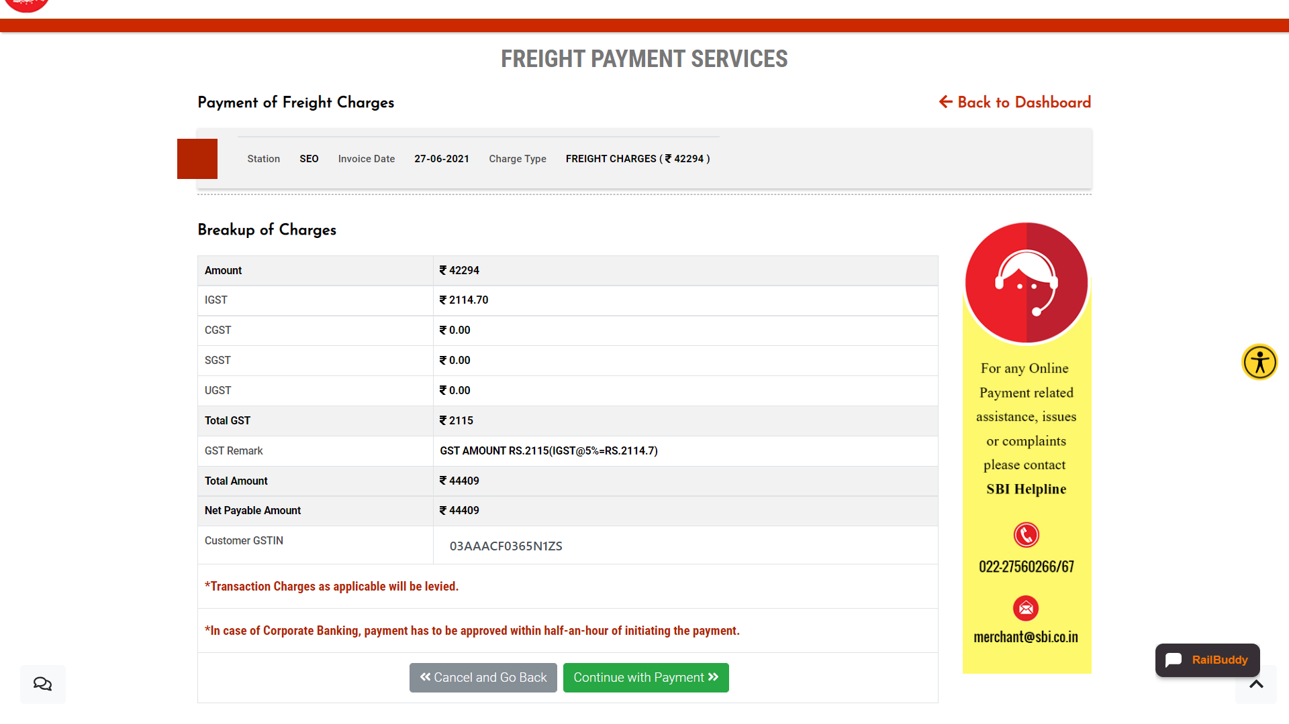

***(*Screen shot for Freight Charges)***

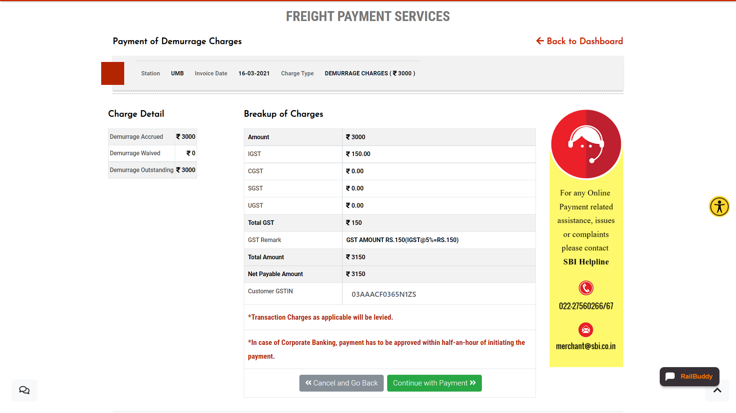

***(*Screen shot for Demurrage Charge)***

**Step 4:** Verify the detail of GST and WRF Adjustment (if any for Freight Charges) and Net Payable Amount calculated there-on, at the confirmation page**.** In case of any assistance or query regarding freight payments, may check **Help & Support** Section or directly contact **IR Freight Officials** through **RailMadad** application (**Contact Us** Option). If everything is in place, may **Continue with Payment.**

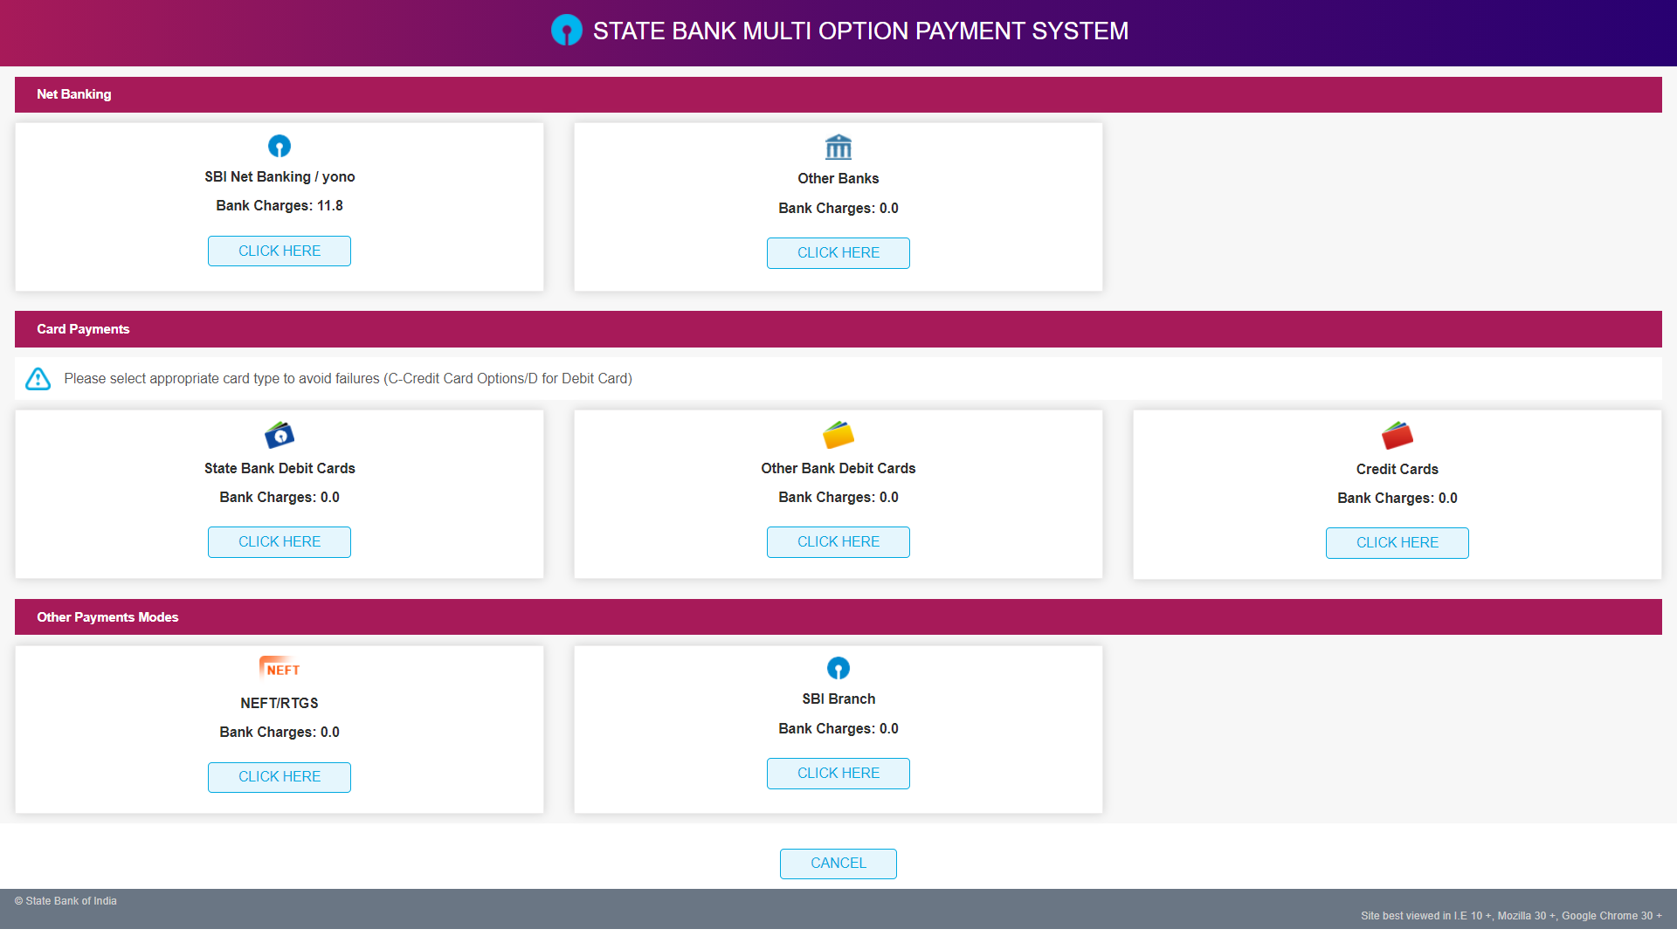

**Step 5:** Select your preferred mode of payment, amongst the various options available on SBI Payment Gateway:

**SBI Net-banking, other banks online banking, Debit Card, Credit Card, NEFT/RTGS etc.**

Login to your selected payment mode

****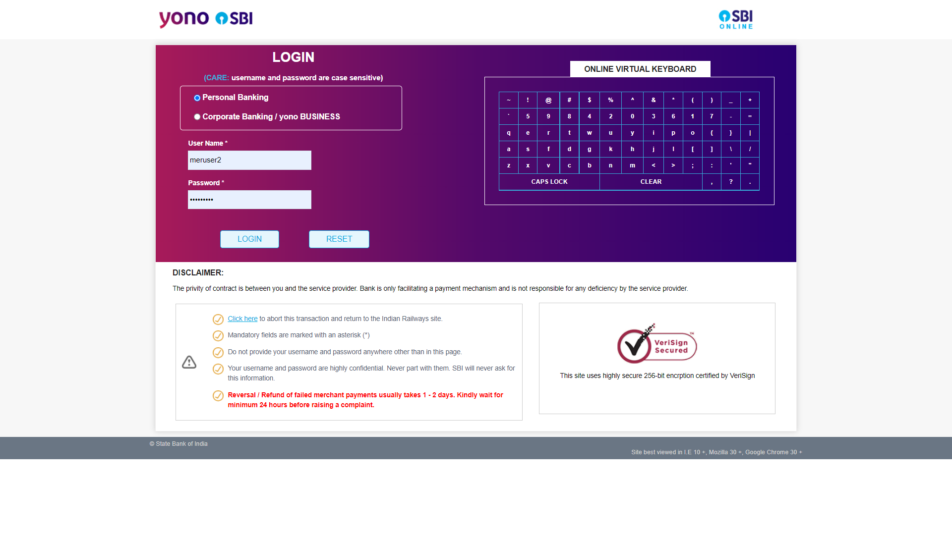

**Step 6:** Verify the payment amount and confirm the transaction.

****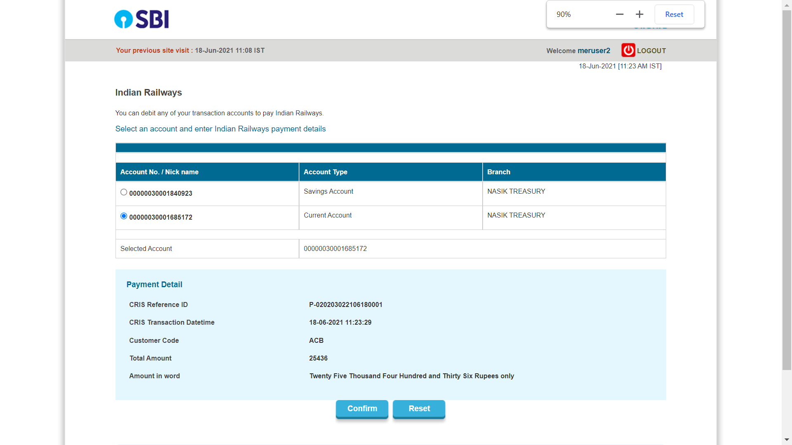

**Step 7:** After successful payment, user shall be redirected to FBD Portal- Payment Confirmation Page.

****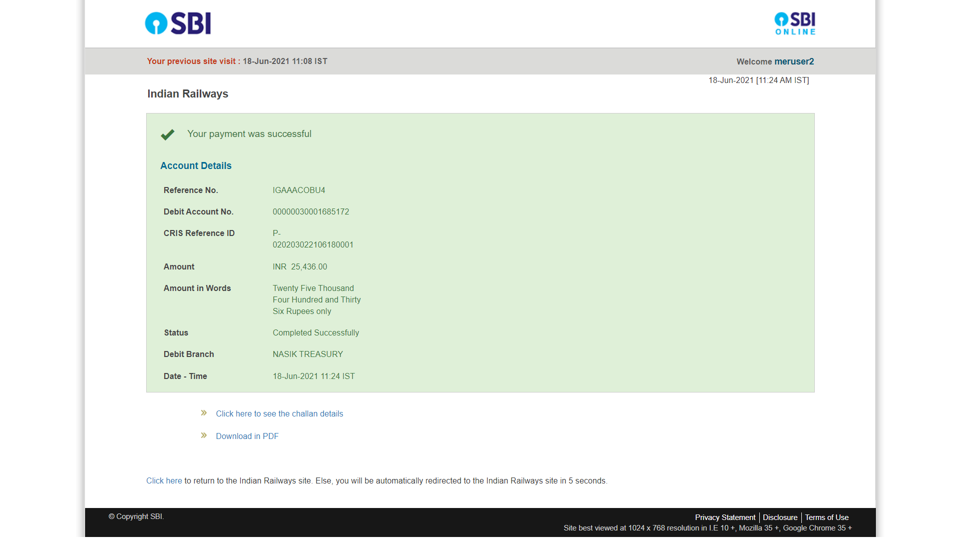

**Step 8:** User maykeep note of Bank Transaction ID and IR Transaction Reference ID for future reference. In case, user experiences any aberration in the payment process, may contact SBI Helpline, available 24x7.

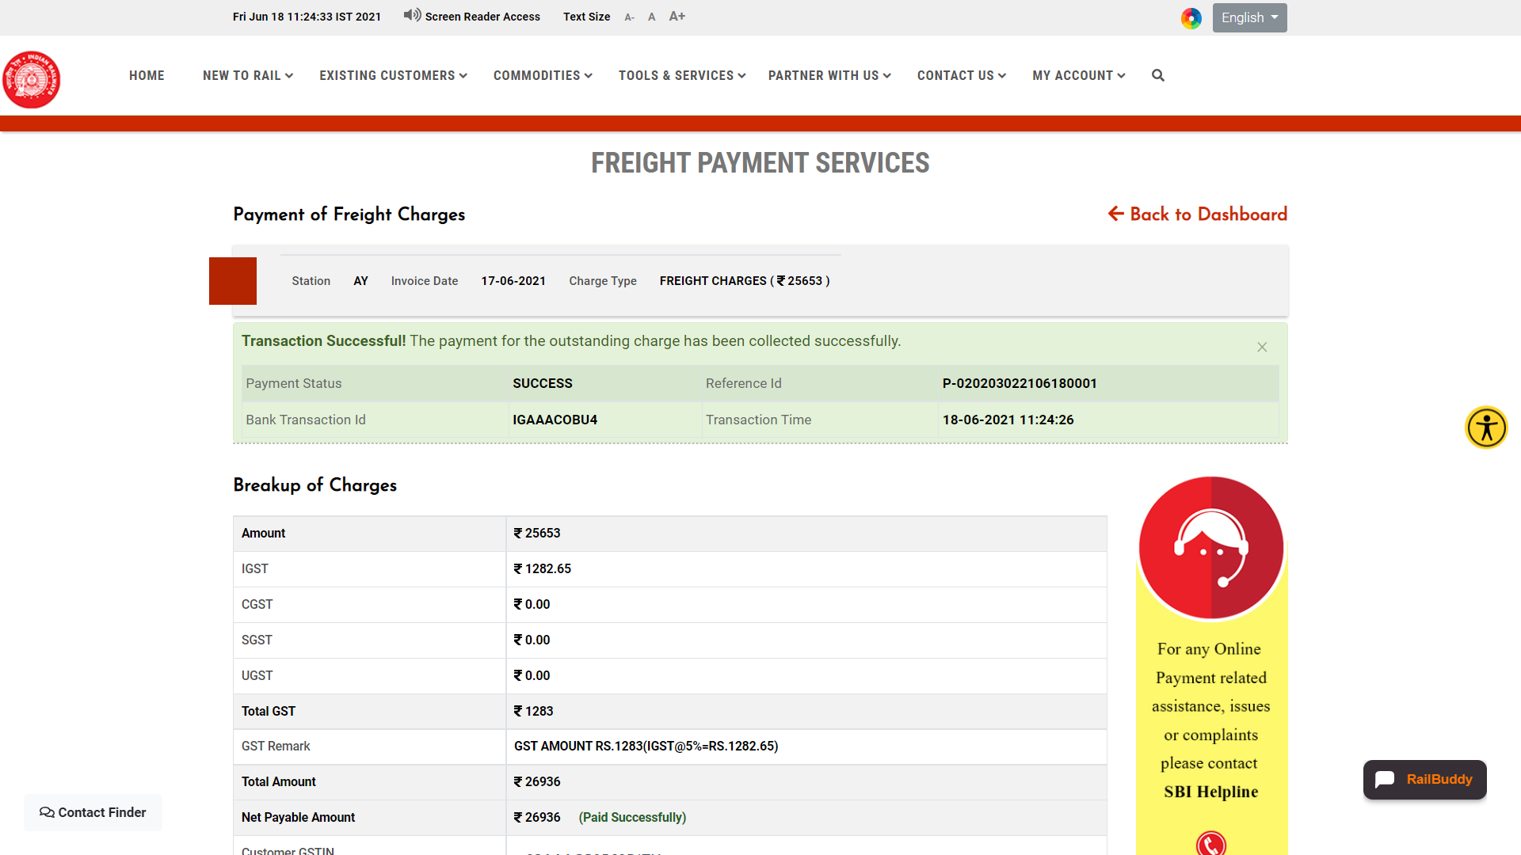

**Step 9:** Go **Back to Dashboard** for further monitoring and analysis of customer’s freight business with Indian Railways.

****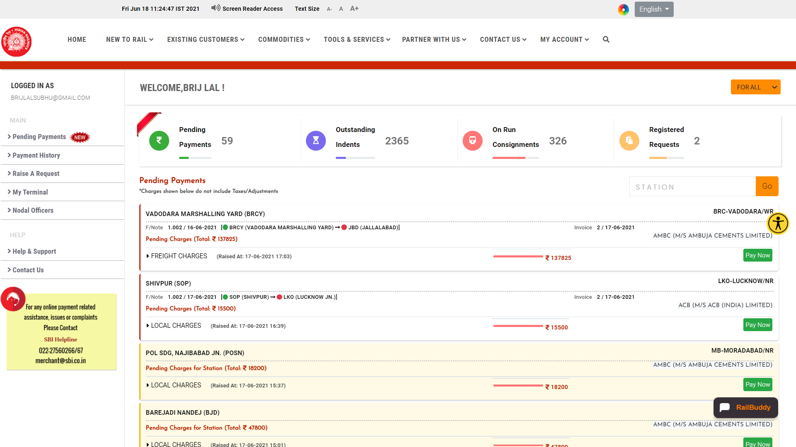

**Payment History**

This feature provides a comprehensive view of the payments made by user for different types of charges viz. Freight Collection, Demurrage charges, Wharfage Charges, Wagon Registration Fees and other Ancillary Charges along with their status. The user can also download the money receipt for successful payments from this view.

Payments made by Secondary Customers (Handling Agents) on behalf of Primary are highlighted separately (light green background) in this view.

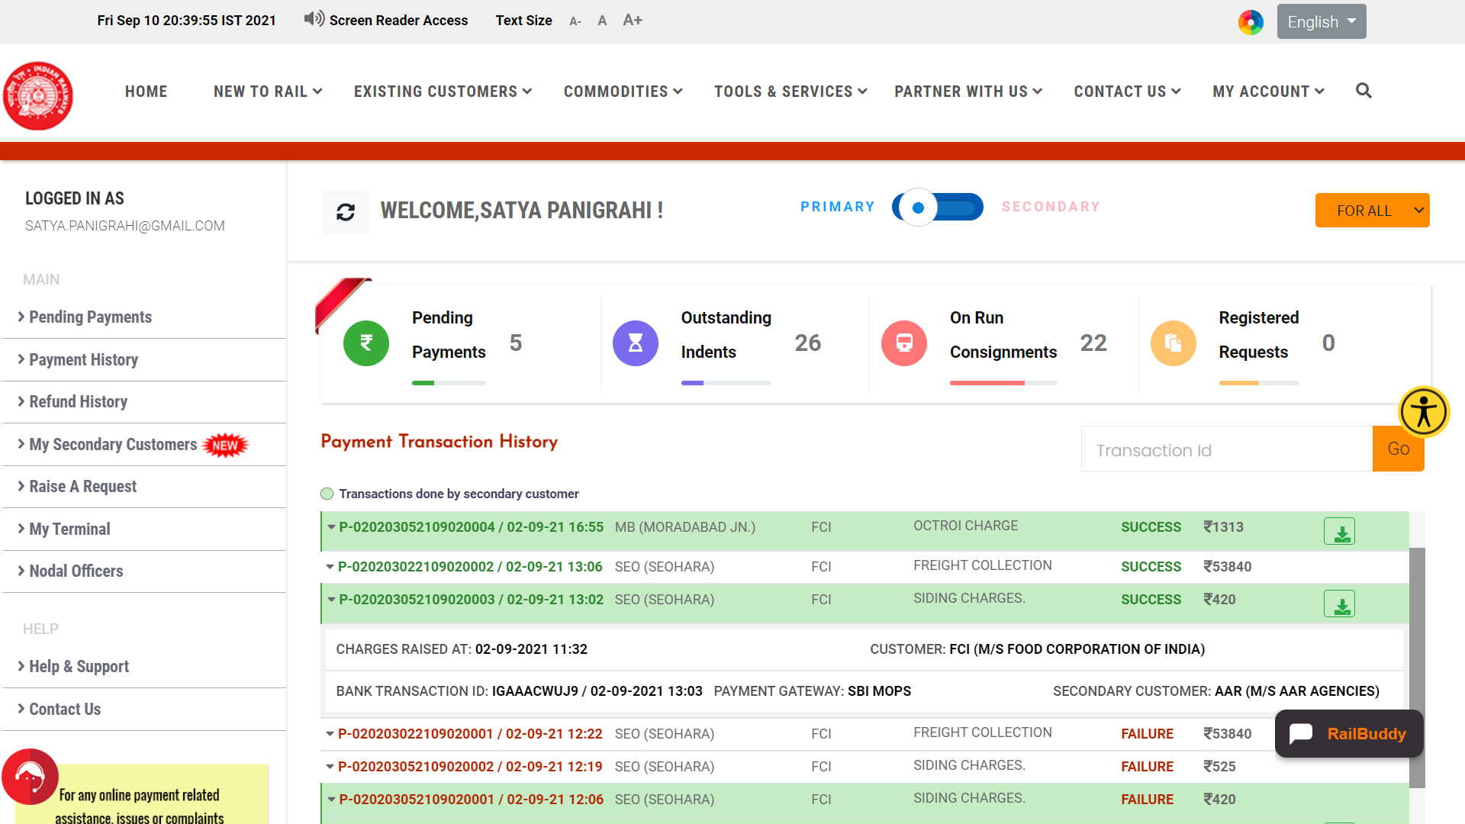

**Refund History**

All the refunds raised against any of the payments (viz. Freight, Demurrage, Wharfage, Ancillary Charges etc.) are available through **Refund History** option.

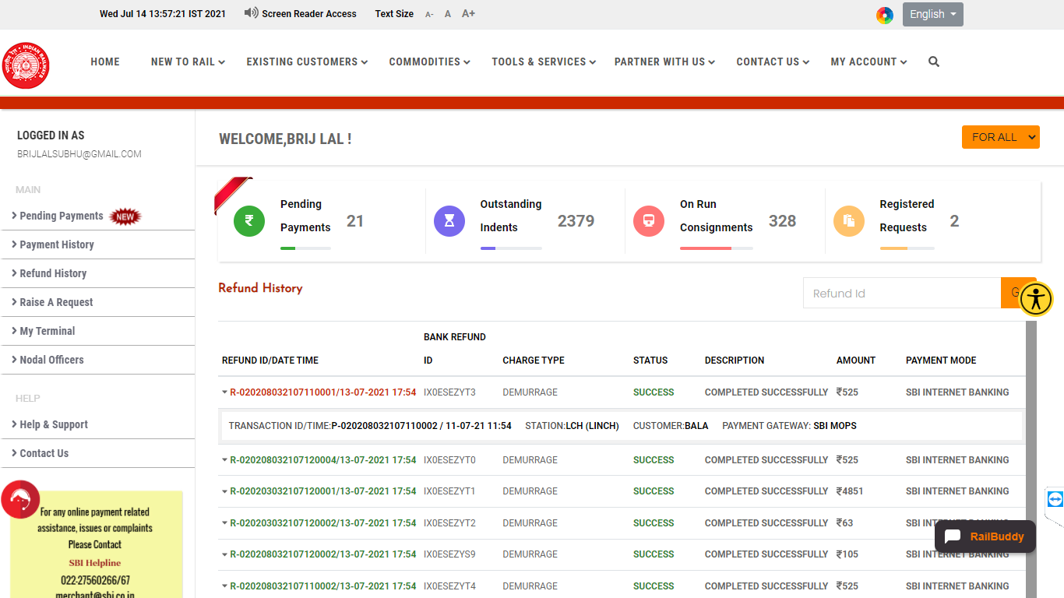

**My Secondary Customers**

This module facilitates the user to add handling agents as secondary customers.

**Register Secondary Customers**

**Step 1:** In the customer dashboard, click on **My Secondary Customers** to view the detail of existing Secondary customers for the user along with the locations (Zone, Division and Stations) and effective dates.

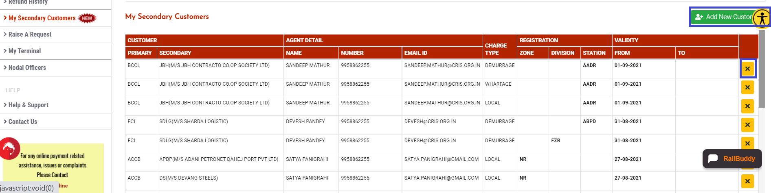

**Step 2:** User may click on **Add New Customer** button to add new Handling agent(s). May select the Primary Customer Code and fill Secondary Customer Code from the available list, Mobile Number or EmailId (atleast one of these has to filled) and click the **Fetch** button. In case user wants to delete a record for an existing secondary customer he may click the **x** button against the record.

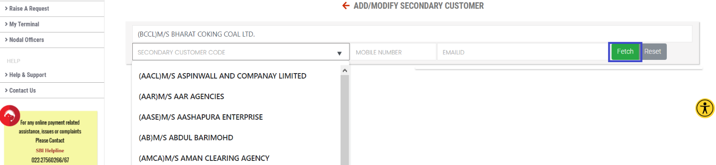

**Step 3:** List of all the handling agents satisfying the given inputs will be displayed. The user may click on the desired detail which shall populate the frame on the right side with the eligible locations.

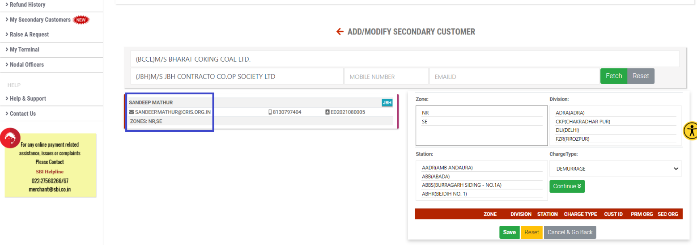

**Step 4:** The user may now select the locations for which he wants to register the secondary customer. Multiple locations may be selected by pressing the CTRL key while clicking. After the locations and charge type have been selected, user may press the **Continue** button which shall result the data being listed in the table below. In case the user wants to remove an entry from the table, he shall click the **x** button against that row. Now the user may click **Save** button to finally save the details.

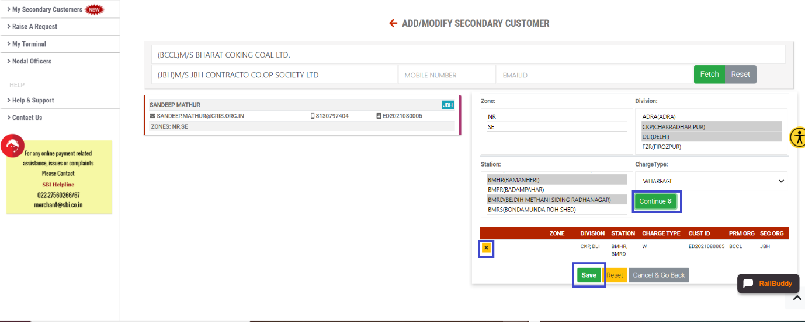

During any stage of payment process, concern(s) may be raised to IR freight officials through **RailMadad** Application (**Contact Us** Option)

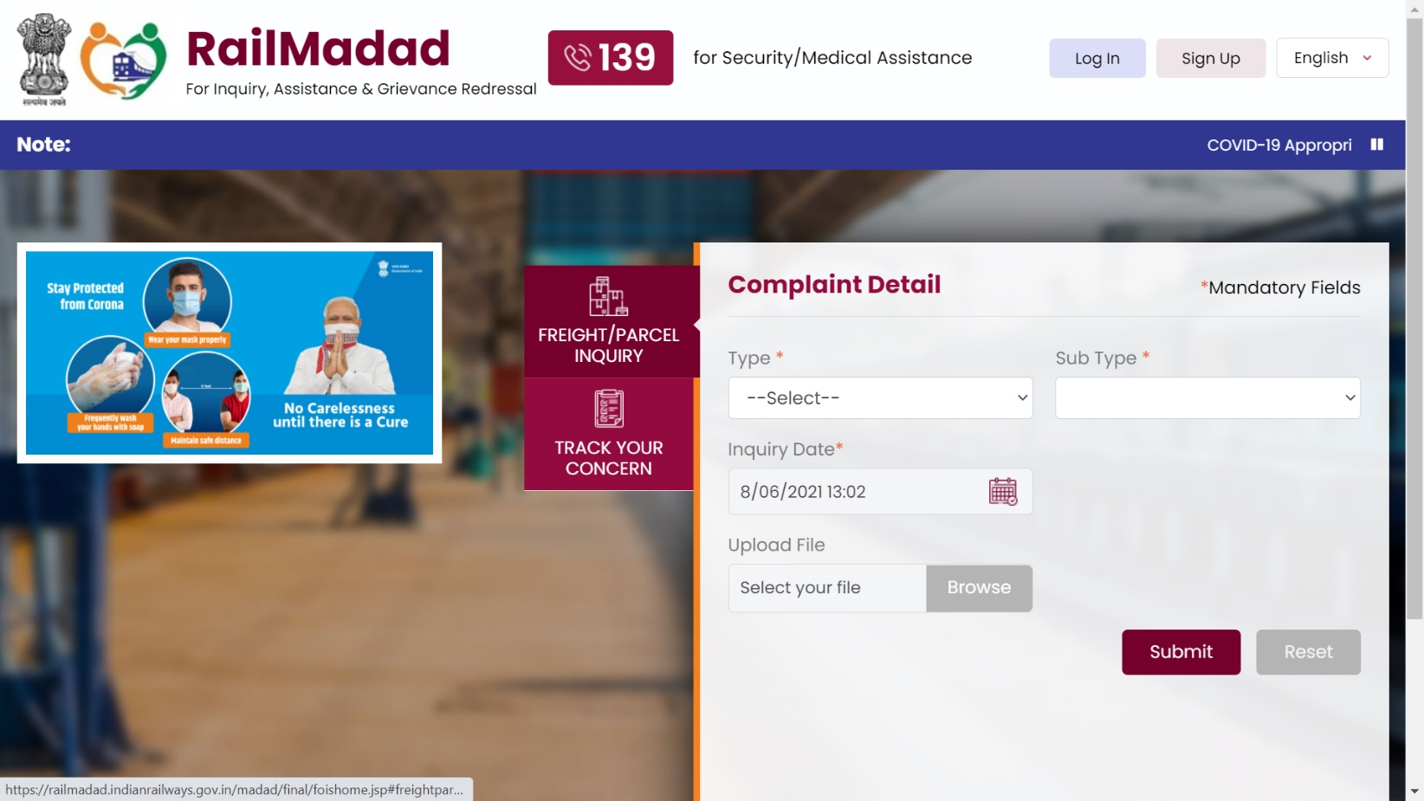

There’s an extensive set of Frequently Asked Questions (FAQs), dedicated to this payment process, providing clarifications on various topics! FAQs may be accessed through **Help & Support** Section.

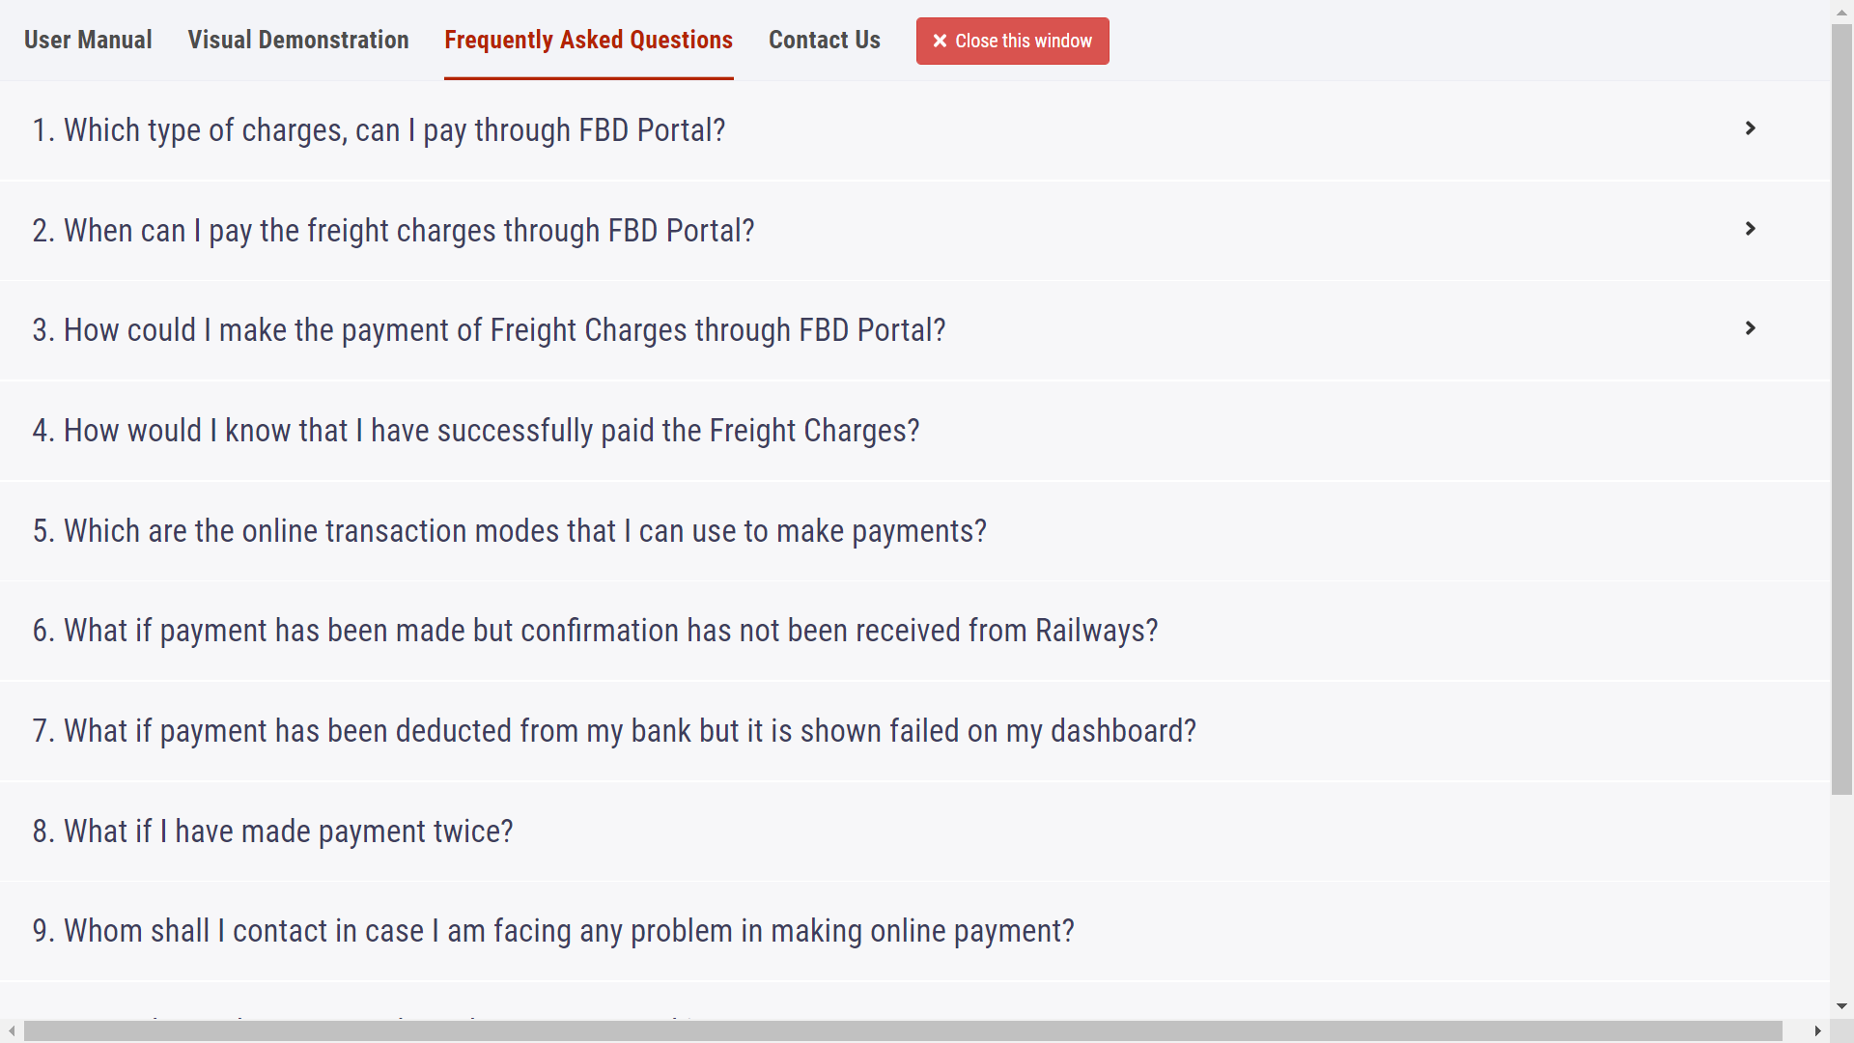****

**INDIAN RAILWAYS - FREIGHT BUSINESS DEVELOPMENT PORTAL**

***EXPERIENCE THE CHANGE…***